**PERSONAL INTRODUCTION:**

Student ID: S3801846 Email: s3801846@student.rmit.edu.au

My name is Tayla Jean Surmon I am 24 years old. I was born and bred in Cairns, Far North Queensland. I completed my year 12 certificate at St Marys Catholic College in 2012. During my years at high school I had the burning desire to move into higher education and complete a degree in occupational once I completed my year 12 certificate, however I put that on hold took a gap year and unfortunately didn’t follow that desire, instead found happiness in working as a gymnastics coach (which I had already been doing since 2007) . My Mum was born in Sydney, however had the opportunity to travel far and wide as her dad was a plane engineer. My Dad is from Papua New Guinea and moved to Sydney Australia at the age of 6. I have 3 Older brothers all of which were born in Sydney. My first and only spoken language is English, however I would like to learn Japanese in the future. Between 2016 and the beginning of 2019 I worked as an insurance broker and gained my Tier 2 in General Insurance Broking. Currently I am working in a bank and in the process of completing my Tier 2 in Banking. I have a dog named Bruce and a cat named Mitsy who I absolutely adore. Up until 2013 I was a Gymnast/Trampolinist and extremely enjoyed it. My early retirement from Gymnastics/Trampolining came in 2013 when I decided that my knees and body was no longer able to take the harsh impact of the sport. 7 years later I decided it was time to jump back into full-time study and am now in the process of completing my Diploma of Business (Financial Planning).

**MY IDEAL JOB:**

My ideal job would be as a Senior Financial Advisor – Family Office Environment. This is a role that I would be able to showcase my excellent track record of Consultative Sale Skills, the ability to hold myself accountable for the results I provide, wow my colleagues with my outstanding communication, presentation and interpersonal skills as well as show that I can work individually as well as in a team environment. Although at this point in time I have very limited knowledge in this industry, I have worked as an Insurance Brokers for 3 years and currently working in a big 4 bank as a personal banker. By participating and completing my Bachelor of Business majoring in Financial Planning as well has having my qualifications from the Insurance industry and the Banking industry I believe that this is just one small leap that I need to take to begin my journey to be a successful Senior Financial Advisor.

**MY TEST OUTCOMES:**

##### **PERSONALITY, CREATIVITY AND LEARNING STYLE TESTS**

## The Myers and Briggs Personality Test (Courtesy of 16Personalities)

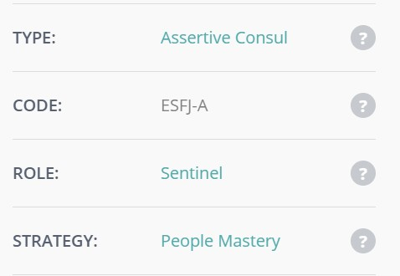

**Creativity Test (Courtesy of MindTools)**

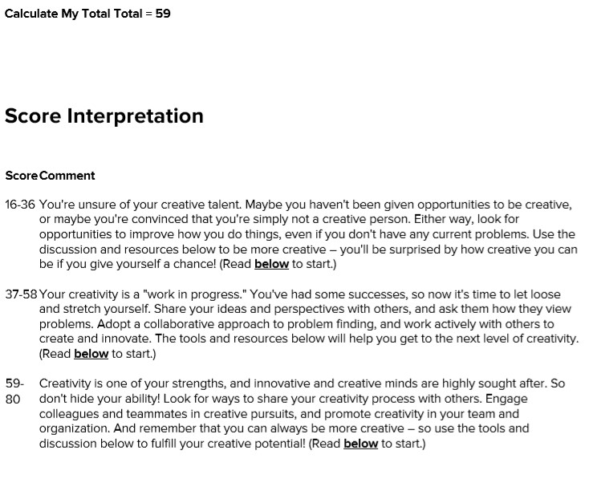

#### **What is your Learning Style (Courtesyof EducationPlanner.org)**

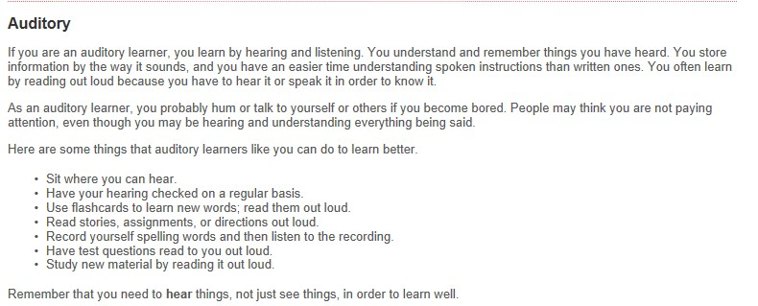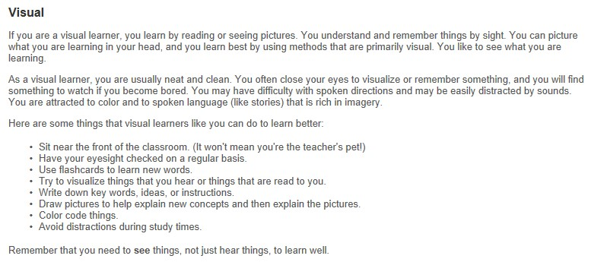

**TECHNOLOGIES THAT IMPACT THE WORLD – AUTONOMOUS VEHICLES:**

From cruise control to parking assist, in the last few years we have seen an enormous escalation in technological developments being executed in the automotive industry.

The human population like to watch movies, don’t have much time to catch up on emails and tend to be a little bit sleep deprived. However, with the production of autonomous vehicles right around the corner people will be able to sit in their car watch movies, catch up on their emails and take a little nap.

An Autonomous Vehicle, is also recognized as a robotic car, self-driving car or a driverless car. This is a vehicle that has the ability to sense its surrounding and move about with little to no human input. Instruments such as radar, lidar, sonar, GPS, inertial measurement units and odometry are all combined within the Autonomous Vehicles which enables them to observe their surroundings and move freely. Advanced control systems translate sensory data to recognize the appropriate navigation paths as well as any obstacles and signage which are essential to be avoided.

Autonomous vehicles are set to be as life-changing if not more life-changing then the invention of the motor vehicle itself. Many cities have been designed principally by the mobility that has been accomplished by motor vehicles. Motor vehicles have provided transportation services to people and supported many major road networks internationally since they were invented.

Many people believe that the analogy of road networks are similar to blood vessels. Road networks give increase to movement and a measure of independence to people giving them the ability to drive from point A to point b and carry out their many social needs and wants as they deem necessary. With the production of Autonomous vehicles, they will make the road network or the blood vessels run more effectively, efficiently and safely.

There is a need for autonomous vehicles to be supported as astonishing statics show that today’s motor vehicles are immensely uneconomical and hazardous.

Research shows that there are around 1 million deaths on the roads worldwide each year. This equivalates to roughly 1 fatality every 30 seconds. Over 90% of these fatalities are caused by human error. Autonomous vehicles have the potential to reduce the amount of fatalities as it eliminates human imperfections in driving such as drivers not paying attention to the road in front of them, driving at high speeds (above the speed limits), drink driving, perceptual errors, judgement errors and driver exhaustion.

Autonomous vehicles are capable of reducing up to 90% of wasted commuting, increasing car utilisation, reducing car ownership and also reducing CO2 emissions therefore also helping reduce global warming.

Within the next few years companies such as Tesla, Toyota, Google, Lexus, BMW, Mercedes-Benz and many more will be arranging to introduce autonomous vehicles with a huge emphasis on the electrification of cars. With autonomous vehicles being produced and ready for sale to the public in the not so distant future we may start to see driver’s licences approach the obsolete status along with hot rod fuel guzzlers.

Within the next 10-20 years the world can expect to see major changes in the way all roads and transport services are operated. This will also create new avenues for value creation in transport such as service and major upgrades in safety and efficiency.

Although Autonomous Vehicles are equipped with Instruments such as radar, lidar, sonar, GPS, inertial measurement units and odometry there are proven difficulties when it comes to determining the intentions of pedestrians, cyclists and animals.

Currently in Europe, Belgium, France, Italy and the United Kingdom are all planning to operate transport systems for autonomous vehicles. Germany, the Netherlands and Spain all currently allow the public to test autonomous vehicles on their roads. In 2015, the United Kingdom launched public trials of the LUTZ Pathfinder automated pod in Milton Keynes. At the beginning of the summer of 2015, the French government allowed PSA Peugeot-Citroen to make trials in real conditions within Paris. The association between the French companies THALES and Valeo (provider of the first self-parking car system) is testing its own system for Autonomous Vehicles. In New Zealand the government in planning to use automated vehicles for public transport in the cities of Tauranga and Christchurch.

In China, Baidu and King Long produced the automated minibus, a vehicle containing 14 seats without a driver’s seat. With 100 vehicles produced by Baidu and King Long, 2018 was the first year with commercial automated services in China.

The era of autonomous vehicles is here. According to the automotive industry estimates, by 2020, the autonomous vehicle market will be worth around US$87 billion (AUD$124,410,000,000). Additionally, by the year 2040, it is projected that out of every 10 vehicles on the road 4 of them will be autonomous. Autonomous Vehicles will open up new opportunities and create motivation for innovation for organisations from across a wide range of industries not only within Australia but Worldwide as well.

In the 2019 Autonomous Vehicles Readiness Index (AVRI) Australia dropped from 14th place to 15th place. The AVRI tested 25 countries on their preparedness to transition to driverless transport in multiple areas including policy, technology, infrastructure and customer acceptance.

In 2017, both the public and private sector senates of the road industry of Australia decided that for Australia to meet the pace of technological progression, the Australian specialists were required to be ready to support the safe deployment of partially robotic vehicles by the year 2020 and highly automated and driverless automobiles by the year 2030.

Unfortunately, with the world we are living in it won’t be long before your everyday manual and automatic cars are non-existent. Autonomous vehicles are the way of the future and within the next 1-5 years they will be everywhere. No more jobs for taxi drivers, bus drivers, truck drivers. All these people will lose their jobs because autonomous vehicles are being manufactured quicker and more frequently as the years go by. Companies will look to become more futuristic by buying autonomous vehicles to reduce their staffing costs. Unfortunately, this is something that we are unable to stop from happening. Not only will loss of jobs be affected but the technology to run the autonomous vehicles will be highly expensive. The world should also see a reduction in taxes as well as insurance collection. Although, these drawbacks will not be sufficient to halt the study and progression that is already underway.

In relation to the effect that autonomous vehicles will have on me personally I believe that it is the way of the future and this is just the start to many autonomous things. I don’t 100% agree with autonomous vehicles but facts such as reducing fatalities worldwide, reducing CO2 emissions and assisting with reducing global warming I agree with the production of autonomous vehicles. However, I don’t agree with how this will affect people’s jobs and livelihoods.

OUR GROUP PROJECT IDEA - MISUSE OF PRESCRIPTION DRUGS

In Australia the use of prescription drugs is an increasing problem. Pharmaceutical drugs have been the highest recurrent contributor to overdose deaths within Australia. Australians who are affected by the dependence of prescription drugs find themselves going from doctor to doctor and pharmacy to pharmacy every day to assist in feeding their addiction. In saying that, this project idea would need to be applied by pharmacists using a computer program that they all must. This program would provide them the ability to search using the customer’s details and find out where else they have been to collect this drug as well as when they last filled a prescription. This is a system that would need to be executed in every pharmacy in Australia and always be used to update the patient records of how often the drugs are being acquired and used.

Not only is this a snowballing issue in Australia, but a worldwide issue which is a growing concern to all governments. A survey which was completed in 2013 found that 4.8% of Australian Adults were using prescription drugs for non-medical purposes. The amount of people in syringe and needle programs who have testified that the most recent drug they used to inject themselves with was a prescription opioid amplified from 7% in 2000 to 23% in 2015. This study also found that the 2 most commonly abused drugs were analgesics and sedatives. The reason these 2 drugs are the most commonly used is because they stimulate the reward section in the brain by increasing the level of dopamine neurotransmitter levels, which creates the feeling of pleasure and relief of dysphoria.

By implementing this service to pharmacies, they would all need to have a protected internet connection which would be linked to a certain server which is based in the cloud. This server would be available 24 hours a day 7 days a week. This system would work by all pharmacists (or pharmacist assistants) inputting the details of all of their clients and the drug that was prescribed to them. Yes, this may take a bit of extra time for the pharmacist or pharmacist assistant, however it would assist in decreasing the abuse of prescription drugs. As this would be a live system that would be hosted by a government agency, all the data that is entered into the system would be live as soon as it is entered, thus there would be no down-time. If an abuser is going from doctor to doctor and pharmacy to pharmacy this would be an excellent program to guarantee that abusers aren’t able to feed their addictions by abusing the medical professions, as they would be red flagged in the system.

If this program is implemented across the globe, it will help a lot of people who are in desperate situations to get back to better health and to return from being dependent on drugs. As mentioned before the computer program would track customer’s prescription orders to limit their use of prescription drugs. As soon as a person is flagged in the system, a response to the situation would be to send a qualified person from a rehabilitation centre with authority from the government. Helping the citizens get back to health is a major part in keeping a community strong and most of all safe. Rehabilitation centres would have personnel ready for tracking and escorting the addict in need back to the centre where they would get the proper care and help. Those who are flagged by the program would be listed in “red” meaning; in need of help. After the addict has received the care and rehabilitation they require from the centre, they would be released back into society as “green” meaning they have been rehabilitated and are now trying to return to a normal life style. The live system would then keep track of their state to make sure they do not relapse. This information will also help doctors determine who the patients are and what to do with their condition.

This type of service would necessitate each pharmacy to have a securely connected computer, which the government would make compulsory to operate. Unfortunately, this means that pharmacies would have to invest a bit of money and time into obtaining these specialised computers or they would be unable to remain operating. As this service is a program that would hold sensitive information about customers, it is highly important that the software development for this program is exceedingly secure.

There are many skills and talents that would be essential to make this project an effective one. Everything from project managers, software developers and computer installers that have experience installing computers that have a secure internet connection. The team of project

managers would need to have a lot of experience and knowledge in every area of network design. The software developers also need to have a lot of experience as they have to work together to create an extremely secure program that is to be run off the cloud. Not only does the program have to be secure to protect the confidential customer information, it also needs to be able to generate red flags when it sees there is a misuse or high use of prescription drugs.

If this project idea was successful in being created it would have an enormous impact on the diverse communities in Australia, as it would see an instantaneous decrease in the prescription drug abuser community. This system will help ensure that patients are filling their prescriptions appropriately and at the recommended time by a doctor (for example, if a patient is prescribed an opioid drug, they are only able to refill this prescription every 30 days, therefore a red flag would be applied with a patient attempts to refill the script before then). This system would be one of a kind as it would be assisting with reducing the amount of prescription drug deaths and overdoses within the Australia community. This would then further assist doctors with being able to see those patients who truly need their care and attention and reduce the number of pointless visits from prescription drug abusers.

REFERENCES

16 Personalities. 2011-2019. Free Personality Test. NERIS Analytics Limited. [Free Personality Test](https://www.16personalities.com/free-personality-test)

EducationPlanner.Org. 2011. What’s Your Learning Style?. Pennsylvania Higher Education Assistance Agency. [What's Your Learning Style? 20 Questions](http://www.educationplanner.org/students/self-assessments/learning-styles-quiz.shtml)

Mindtools.com. 2019. How Creative Are You?. Mind Tools Essential skills for an Excellent Career. [How Creative Are You?](https://www.mindtools.com/pages/article/creativity-quiz.htm)

Benny Monheit, Danusia Pietrzak and Sandra Hocking. 2016. Prescription Drug Abuse – A timely update. A Family Physician. [Prescription drug abuse – A timely update](https://www.racgp.org.au/afp/2016/december/prescription-drug-abuse-a-timely-update/)

Autonomous Car. 2019. Autonomous Car - <https://en.wikipedia.org/wiki/Autonomous_car>

# Nadine Cranenburgh. 2019. Is Australia ready for self-driving cars.

<https://www.createdigital.org.au/australia-ready-for-self-driving-cars/>

Mandla Reissmann. 2019. The Future of Autonomous Vehicles.

<https://www.futuresplatform.com/blog/future-autonomous-vehicles>

Victoria Woollaston. 2018. Driverless cars of the future: How far away are we from autonomous cars?. <https://www.alphr.com/cars/1001329/driverless-cars-of-the-future-how-far-away-are-we-from-autonomous-cars>

Alex Davies and Aarian Marshall. 2019. Are we there Yet? A reality check on self-driving cars. <https://www.wired.com/story/future-of-transportation-self-driving-cars-reality-check/>

Ian Dowd. 2019. The future of Autonomous Vehicles. <https://www.openaccessgovernment.org/future-of-autonomous-vehicles/57772/>

Jessica Miley. 2018. Are Self-Driving Cars the Future of Transportation?. <https://interestingengineering.com/are-self-driving-cars-the-future-of-transportation-infographic>